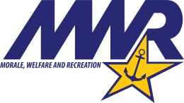
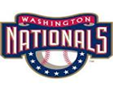
ITT Indian Head – 301-744-4850
Information, Tickets and Travel Outlet
89 Bennion Road, NSA Annapolis, 21402
NATIONALS BASEBALL TICKET REQUEST – 2026

CUSTOMERS NAME: ___________________________________
EMAIL (non-government): _________________________________________
PHONE: ______________________________
Seating Area | Game Date | Number of tickets Requested | MWR Price | Price Includes Food & Beverage voucher
PNC Diamond Club |  |  | $242.00 | All inclusive
Dugout Box |  |  | $131.00 | $25.00
Infield Box  Sections 114-120, 126-131 |  |  | $103.50 | $20.00
LF/RF Baseline Reserved  Sections 111-113, 132-134 |  |  | $78.25 | $15.00
LF/RF Corner  Sections 108-110, 135-137 |  |  | $65.00 | $10.00
RF Mezzanine  Sections 201-205, 223-225 |  |  | $56.25 | $6.00
Upper Infield  Sections, 403-409, 416-420 |  |  | $26.50 | $0 (N/A)
Order tickets at least twoweek in advance of game date. Tickets are filled on Wednesdays and Fridays.
To order: Bring form to MWR Tickets, NEX/Personalize Services or call. (Phone: 410-293-9200)
Marquee and Diamond games are on variable price scale
LF Mezzanine tickets are no longer available

